Normal Distributions

I. Shade in the appropriate area on a normal graph. After you have shaded in and marked your graphs, for 1-7 below compute the proportion of a standard Normal model that is found in each region – use normalcdf. In 8-10 find a where you are given the proportion in a region – use invNorm. (SHOW CALCULATOR INPUT)

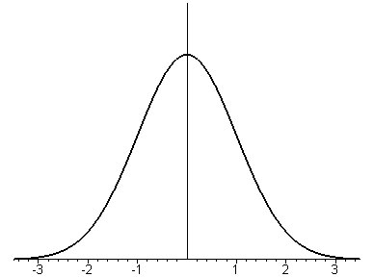

1. P(Z < 1.50)

Normalcdf( _____, _____, _____, _____ )
2. P(Z < –2.30)

Normalcdf( _____, _____, _____, _____ )

3. P(Z > 2.75)

Normalcdf( _____, _____, _____, _____ )

4. P(Z > –1.00)

Normalcdf( _____, _____, _____, _____ )

5. P(Z < 2.50)

Normalcdf( _____, _____, _____, _____ )

6. P(1.00 ≤ Z < 2.50)

Normalcdf( _____, _____, _____, _____ )
7. P(–1.00 ≤ Z < 2.50)

Normalcdf( _____, _____, _____, _____ )

8. P(Z < a) = 0.20

invNorm( _____, _____, _____ )

9. P(Z > a) = 0.10

invNorm( _____, _____, _____ )

10. P(Z > a) = 0.95

invNorm( _____, _____, _____ )

I. 1. 0.9332 2. 0.0107 3. 0.0030 4. 0.8413 5. 0.9938 6. 0.1524 7. 0.8351 8. –0.84 9. 1.28 10. –1.645
II. Scores on a test of U.S. History are normally distributed with a mean of 120 and a standard deviation of 20.

1. Approximately at what percentile is a score of 150?

2. Approximately at what percentile is a score of 95?

3. Find the first quartile for the scores.

4. Find the approximate score of the 91st percentile, P91?

III. Canned tomato sauce is labeled “net contents 230 grams.” A machine fills the cans such that the net contents of a can is normally distributed with a mean of 237 grams with a standard deviation of 4 grams.

1. What proportion of the cans are under filled (i.e. they contain less than 230 grams)?

2. If the government allows only 2% of all cans to be under filled and we assume that we have no control over the standard deviation (it’s a measure of how good the machine is), at what value must the mean fill level be set to meet this requirement?

3. If the filling machine is retooled and the standard deviation is now 2, at what value must the mean fill level be set to meet this requirement?

4*. If the retooled machine will maintain the standard deviation of 2 for the next 100,000 cans it fills, how much tomato sauce is saved.

