A Chi-square Test For Independence

The records of a sample of SCC statistics students are recalled and they are cross-classified by their preparation for the class (the highest prerequisite course they completed) and their grade for the statistics course. The results of the study are in the following two-way table.

1. Fill in the expected values for each cell (use the Minitab printout below for most cells).

 | Statistics Grade
Prereq. Course | A | B | C | Other
Algebra II | 78  ( ) | 115  ( ) | 206  ( ) | 101  ( )
College Algebra | 62  (80.0) | 164  ( ) | 88  ( ) | 86  ( )
Calculus | 60  ( ) | 21  ( ) | 6  ( ) | 13  ( )

2. Verify that (observed − expected)2/expected for the (1, 1) cell is 4.840. This is the contribution of this cell to the Chi-square statistic. Minitab analysis produces:

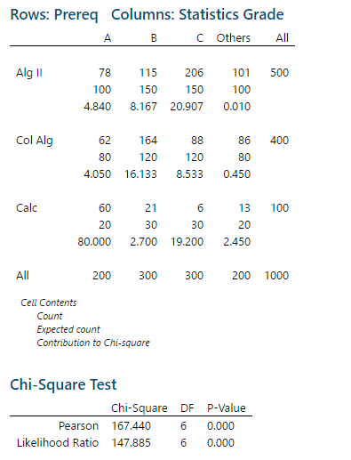

3. State an appropriate null and alternative hypotheses.

H0: __________________________________________________________________

__________________________________________________________________

HA: __________________________________________________________________

__________________________________________________________________

4. What is the observed value of the test statistic? ______

5. How many degrees of freedom are there? ______

6. Compute the P-value? ______

7. Write a complete, carefully worded conclusion?

