ANOVA

Four brands of cigars were tested for tar content. Minitab was used to perform a One-Way ANOVA on the experimental results to determine if there was a difference among the mean tar content of the different brands. The results are below:

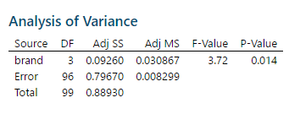

1. State appropriate null and alternative hypotheses.

H0: _______________________________________________

HA: _______________________________________________

2. What are the degrees of freedom for this test? (numerator df, denominator df) ( ______, ______ )

3. Use your calculator’s Fcdf function to find the P-value for this test?

input: Fcdf(____________________________________________)

P-value = _____________

4. Write a properly worded and meaningful conclusion. (Use complete sentences please and recall that this must be an answer to the question at hand and not just about null or alternative hypotheses. Do not use the words “null”, “alternative”, or “hypothesis” in your conclusion.)

5. If you concluded that not all the means are equal, based on the 95% confidence intervals in the above printout which pair(s) of cigar (if any) seem to have different mean tar content?

