Lecture Notes (Italics = Handouts)
Chapters 6 (Navidi/Monk)
Discrete Probability Distributions

Section 6.1: Random Variables

A random variable assigns to each element of a sample space a unique numerical value. We use uppercase italicized letters (e.g. X, Y) to denote random variables and lowercase italicized letters (e.g. x, y) to denote values of a random variable.

Examples: flip 3 coins, X = number of heads; 5 M/C questions, X = number correct; roll two dice, X = total number of pips on the upward faces;.

discrete vs continuous (usually count vs measure)

Examples: which are discrete and which are continuous: randomly select a student from the class, X = the student’s height, or number classes enrolled in, wt, # siblings, distance from home to SCC, household income, # in household, ZIP code, units completed

Discrete Probability Distributions

A probability distribution for a discrete random variable specifies the probability for each possible value of the random variable.

These distributions can be given by a table, formula, or a probability histogram

For example:

by table:

x | P(x)
–3 | 0.2
–1 | 0.4
2 | 0.3
5 | 0.1

by formula:

P(x) = x/10 for x = 1, 2, 3, 4

by histogram: (from page 258 in textbook)

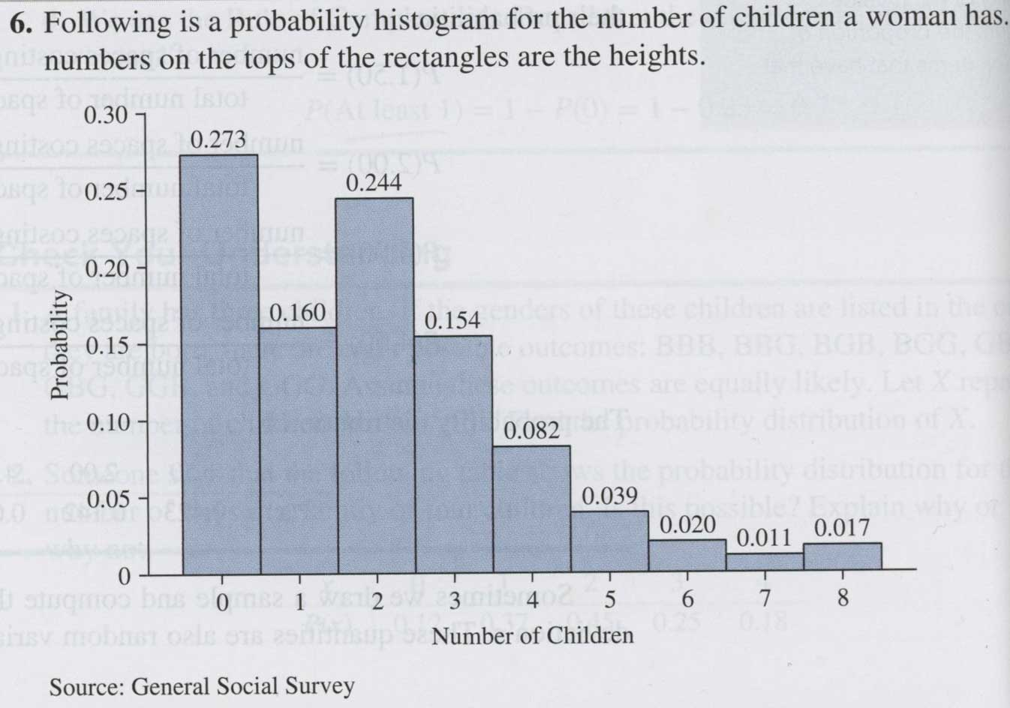

Properties: 0 ≤ P(x) ≤ 1 and ΣP(x) = 1

Mean and Standard Deviation of a discrete probability distribution

Let X be a discrete random variable. For convenience and brevity we will write the P(X = x) as P(x).

Definition: The mean or expected value of a discrete random variable is defined as
μ_{X} = E(X) = ΣxP(x). Note the use of the Greek letter indicating that this is a parameter, not a statistic, it is the mean of a theoretical distribution (the probability model), not the mean of sample data.

The law of large numbers of means states that if we sample from a population then as the sample size grows larger, the sample mean will approach the population mean.

Definition: The variance of a discrete probability distribution is defined by Var(X) = σ_{X}2 = Σ(x − μ)2 P(x).

A computation formula is σ_{X}2 = Σx2P(x)− μ2.

The standard deviation is SD(X) = = σ_{X} = .

Mean and Variance of Discrete Random Variables

Exercises: 1 – 27, 29, 39, 43, 57

Section 6.2: The Binomial Distribution

Binomial Probability Distributions

Note: I’m approaching this from a slightly different angle than the book.

Bernoulli experiment: exactly two outcomes, generically “success” and “failure”, probability of “success” is denoted by p, probability of “failure” is therefore 1 – p. For example: flip a coin, pick a random student and designate as male or female. Often there are more than two outcomes of a probability experiment but we can view it has have just two by designating some of the outcomes as a “success” and the rest as “failures,” for example we may roll an die and consider getting a 1 or a 2 as a “success.”

Binomial Model

A Binomial experiment consists of n independent, identical Bernoulli trials (a longer form of this is in the box on the top of page 269 of the text).

If X is the number of successes for a binomial experiment we then say X has a binomial probability distribution with n trials and the probability of a success = p and we write X ~ Binom(n, p), (note that the probability of a failure can be denoted by q = 1 – p)

Probabilities for binomial distributions (Binomial Distributions)
formula P(X = x) = _{n}C_{x} p^{x} (1 – p)^{n–x}, where
table (rare now with the available technology)

by calculator
For X ~ Binom(n, p) on the TI calculators

P(X = x) = binompdf(n,p,x)
P(X ≤ x) = binomcdf(n,p,x)
P(X ≥ x) = 1 – binomcdf(n,p,x–1)

by computer (Maple, Excel, etc.)

Mean, variance and standard deviation of a binomial distribution

μ_{X} = np σ_{X}2 = np(1 – p) σ_{X} =

Exercises: 1 – 13, 17, 21, 27, 39 (use your calculator)

Note: we are omitting section 6.3

