Solano Community College SPRING, 2012
COURSE SYLLABUS for Math 11 - Statistics


Section #: 11253
Everything
Matters!

Time/ Place: 9:00-12:50 MW / Room 213
Instructor: Charlene Snow
Office: Room 230 – Vallejo Center
Phone/e-mail: 707-864-7000 ext. 4463 / charlene.snow@Solano.edu
Office Hours: MW 9:00 – 10:00 a.m. & TR 11:00 - 12:00
I will be in the MAC: MWF 10:00-10:50

Text: Introductory Statistics by Prem S. Mann, 6th edition (required).

Prerequisite: A grade of “C” or better in Math 104, Intermediate Algebra. Note: One hour per week concurrent enrollment in the Math Activities Center (Math Lab) is required and must be attended a total of 16 hours for the semester. Because of new government regulations, you must attend one hour per week. You may not wait and do all hours at once. If you have not completed 8 hours in the MAC by midterm, I will drop you.

Topics An introduction to elementary probability and statistics, including the basic rules of
covered: probability, probability distributions, descriptive statistics, hypothesis testing, estimation, correlation and regression analysis.

Course As Students will be required to analyze, evaluate, and compare the following basic
Content concepts and processes.
Outline:
I) Descriptive statistics.
A) Organization and presentation of data.
1) Construction and interpretation of frequency and relative frequency
distributions.
2) Graphical methods for presenting data and interpretation of these graphs.
3) Elementary exploratory data analysis including construction and
interpretation of stem-and-leaf displays and box-plots.
B) Statistical measures for single variate data.
1) Definition, computation, and interpretation of measures of central tendency.
2) Definition, computation, and interpretation of measures of variability.
3) Definition, computation, and interpretation of measures of quartiles, deciles,
and percentiles.
4) The "Empirical" rule.
5) Optional: Chebyshev's Theorem
C) Statistical measures for bivariate data.
1) Construction and interpretation of scatter plots.
2) Definition, computation, and interpretation of measures of correlation.
3) Definition, computation, and interpretation of least squares regression line.
II) Introduction to probability.
A) Definitions, examples, and applications of sample spaces and events.
1) Simple events.
2) Compound events.
3) Mutually exclusive events.
B) Combinatorial methods and their application to probability.
1) The basic counting principle.
2) Combinations.
C) Rules of probability and their applications.
1) The "Addition Rule" and the special case for mutually exclusive events.
2) The "Multiplication Rule" and the special case for independent events.
D) Conditional probability and independence.
E) Discrete random variables and distributions.
1) Definition and interpretations of discrete probability.
(a) General discrete distributions.
(b) Binomial distribution.
2) Computation and interpretation of mean and variance.
F) Continuous random variables.
1) Definition and interpretation of density functions.
2) The Normal distribution.
3) Optional: The Normal approximation to a binomial distribution and continuity
corrections.
III) Sampling.
A) Comparison of different techniques of sampling.
B) Definition, examples, and applications of sampling distribution.
C) Central Limit theorem.
1) Expected value of sample means.
2) Standard error of the mean.
IV) Hypothesis testing.
A) General ideas, misuses, types of errors.
B) Tests about the mean of a single population.
1) Criteria for use.
2) z-tests.
3) t-tests.
C) Tests about the proportion within a single population.
D) Tests about the differences in the means of two populations.
E) Paired differences tests.
1) Criteria for use.
F) Tests about the differences in the proportions within two or more populations.
3) Chi-square tests.
(a) goodness-of-fit test.
(b) test for independence.
(c) Optional: tests about the variance.
G) Optional: Tests about the correlation coefficient and/or the slope of the
regression equation.
V) Estimation and application of the estimates.
A) Types of estimators, their advantages and disadvantages.
1) Point estimations.
2) Interval estimations.
B) Bias and unbiased estimators.
C) Estimation of a population mean.
D) Estimation of a population proportion.
E) Estimation of the difference in population means.
F) Estimation of the difference in population proportion.

Expected As a result of successful completion of this course, a student will be able to:
Student 1. Critically analyze statistical information presented in media, journals,
Learning etc.
Outcomes: 2. Convert data to statistical evidence and interpret the evidence.

Supplies: You will need a TI 83/84 calculator. We will use its statistical capabilities. You must use engineering paper or very light graph paper for homework assignments.

Attendance: Students are expected to attend class and to be on time! If you are late, you may be counted as absent. You are expected to stay until the end of class. (If for some reason you must leave early, let me know before class and sit by the door.) If you miss more than 3 classes, you may be dropped from the class. Students are responsible for all announcements during the class (e.g. change in a test date) and all the material covered in class in addition to material indicated on the course outline. Quizzes and in-class assignments are sometimes unannounced and cannot be made up.

Homework: You are expected to read the section of the text from which the homework is assigned. Some homework will be be done using MiniTab, a statistical program which is on the computers in the Math Lab. There are computers that can be checked out and used in the Math Activities Center.
You are encouraged to work in groups, in the Math Activities Center (Math Lab), to compare and discuss the solutions you obtained for your homework assignments. You have to homework somewhere, why not in the MAC?

Method of The primary means of evaluation will be performance on tests and quizzes. *
Evaluation: 100-200 points - homework, pop quizzes, and/or special assignments.
32 points - Attendance in Math Lab – 2 points per hour for 16 hours
400-500 points – 4-5 tests during the term – 100 points apiece
150 points – final exam

90-100% A 60-69% D
80-89% B 59 and below F
70-79% C

Tests: You are allowed NO make-up teSTS! If there is a legitimate reason why you cannot be in class on a test day, let me know BEFORE the test and possibly a time can be arranged to take the test. A test must be taken before it is handed back to the rest of the class. This can only be done once. If another test is missed a ZERO will be given for that test.

Final Exam: The final exam is comprehensive and will be: Thursday, May 17, 8:00 a.m. – 10:00 a.m.

Final Exams will not be returned.

Academic It is the responsibility of every student to read and be familiar with the academic regulations as
Regulations: stated in the current Solano Community College General Catalog. If a student wants to drop a class, it is his/her responsibility to complete a drop card and submit it to the Office of Admissions and Records. If you simply stop attending class and do not submit a drop card to OAR by the last day to drop a full semester course with a “W” grade, a grade of “F” may be assigned. You cannot count on me to remember to drop you!

Honesty: Each student is expected to do his/her own work on exams and quizzes. Students may work together
or obtain tutorial assistance for homework. (Getting help does not mean having someone do it for you!)
The following policy will be used for Cheating:
1) Any student caught (in my opinion) cheating will receive a “0” on that test, quiz or assignment.
2) Any student caught cheating a second time will also be reported to my Dean and/or the Vice President of Student Services for action in accordance with established disciplinary procedures as set forth in Solano Community College Board Policy 5300. Actions may include being expelled, suspended, or placed on social probation.

Mutual Everyone is here to learn. I expect mutual respect – no discounts or put-downs of anyone.
Respect: Disruptive behavior is not acceptable. Turn off cell phones! Whispering to a friend is disruptive and annoying to everyone else. If you cannot refrain from talking at inappropriate times or other disruptive behavior, I may assign you a different seat (usually very close to me), or ask you to leave. A seat reassignment is for the duration of the semester. If asked to leave, do not return until you have spoken with the Vice President of Academic Affairs.

Spring Jan 18 - Spring session begins
Important Jan 29 - Last day to drop full term class and receive refund
Dates Feb 5 - Last day of late Registration
Feb 9 - Last day to apply for Credit-By-Examination
Feb 20 Last day to drop full term class with no course or grade recorded
Feb 17-21 President’s holiday weekend
Feb 19 - Last day to file Pass/No Pass Option for full term classes
March 9 – Student Service Retreat-All Student Services Offices Closed (Financial Aid, Admissions & Records, Counseling, DSP, EOPS, Assessment, Vacaville Center, Vallejo Center, Student Development, Community Services, ID Station, MESA, Health Center, Veterans)
March 14 - Faculty In-Service-No Classes
March 31 Optional Flex-No Classes
April 1 - Last day to drop full term class with a “W”
April 6 Last day to file for degrees and certificates
April 7-13 - Spring Break-College Closed
May 17-22 - Finals
May 23 - Spring Term Ends/Graduation

All lectures will be posted on mathsci.solano.edu, Charlene Snow, Math 11 Statistics SPRING 2012
(Notice – no www)

Some rooms on campus are important to this class. They are highlighted in red below.

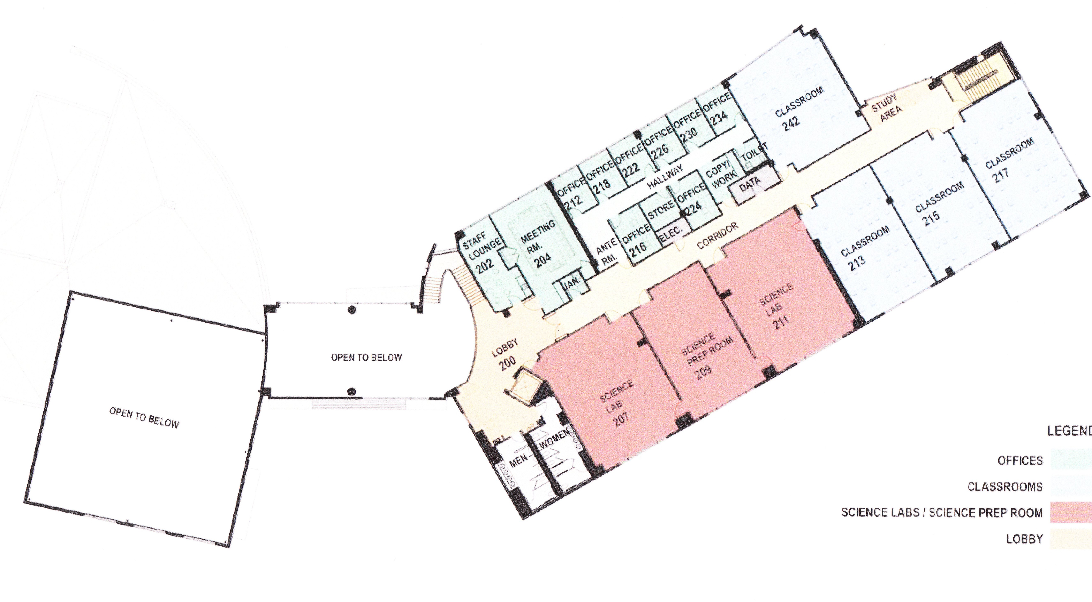
My Office
RM 230
Second Floor Plan
Classroom
213

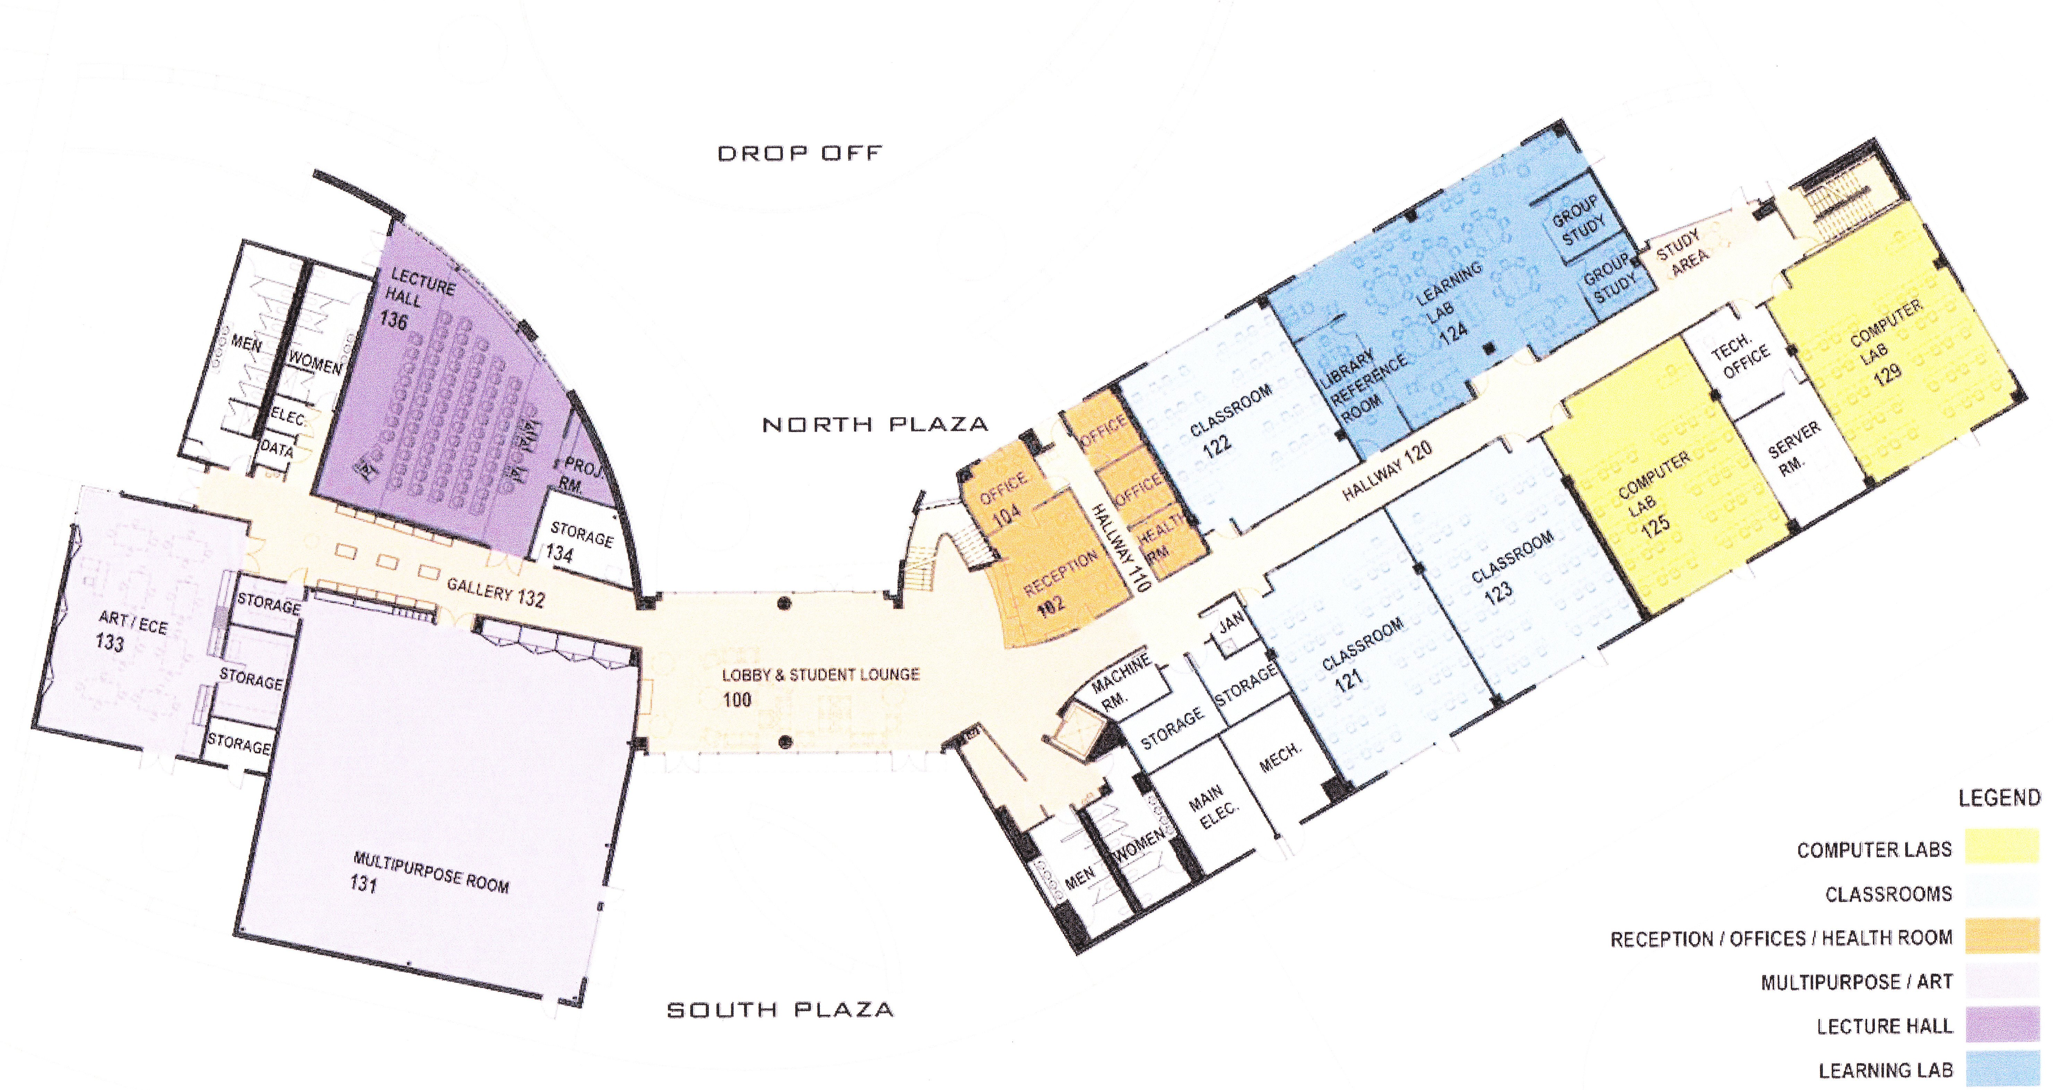
First Floor Plan
Learning Lab
Room 124

NOTE: The instructor reserves the right to change the syllabus and course outline at any time.
Students will be notified of changes in class.
* I reserve the right to make adjustments to the grading scale to cover special circumstanced – i.e. high score on the final, excessive absences, etc. Final grades will be determined by a total of scores on quizzes, homework, MAC hours, major exams and the final. At no time will grading be done on a curve.

