Solano Community College Spring, 2012
COURSE SYLLABUS for Math 330 - Elementary Algebra
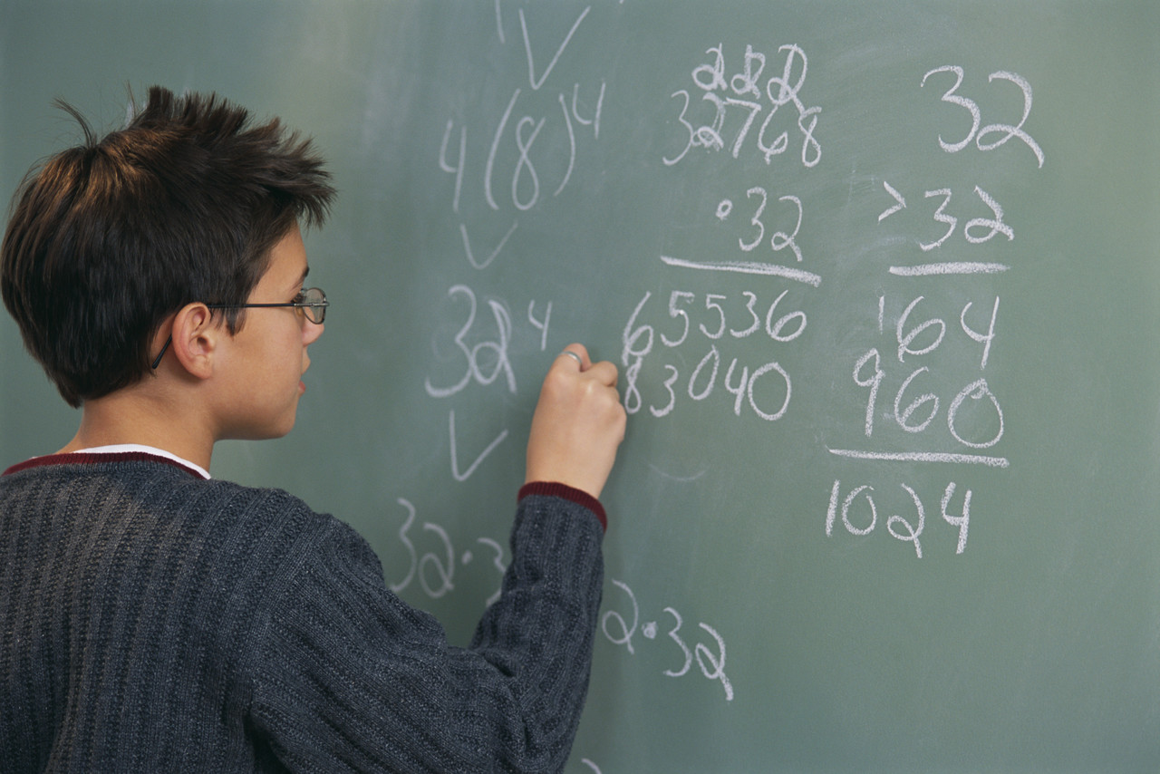

Section #: 11262
Everything
Matters!

Time/ Place: 11:00-12:25 MWF / Room 213
Instructor: Charlene Snow
Office: Room 230 – Vallejo Center
Phone/e-mail: 707-864-7000 ext. 4463 / charlene.snow@Solano.edu
Office Hours: MW 9:00 – 10:00 a.m. & TR 11:00 - 12:00
I will be in the MAC: MWF 10:00-10:50

Text: Elementary Algebra by Charles P. McKeague, Solano Custom 8th Edition (required)

Prerequisite: A grade of “C” or better in Math 320, Pre-Algebra. Note: One hour per week concurrent enrollment in the Math Activities Center (Math Lab) is required and must be attended a total of 16 hours for the semester. Because of new government regulations, you must attend one hour per week. You may not wait and do all hours at once. If you have not completed 8 hours in the MAC by midterm (end of 8th week), I will most likely drop you.

Topics Introductory examination of the structure of the number system. Covers such topics as an
covered: introduction to set operations, the field axioms of the real numbers, and the properties of whole numbered exponents. Emphasizes operations with fundamental expressions; solutions of first degree equations, inequalities and linear systems. Introduces absolute value, radical and quadratic equations, applied problems involving first and second degree equations in one variable, point-slope and slope-intercept equations of lines and their graphs, and concepts of relations and functions

Course Students will be required to analyze, evaluate, and compare the following basic concepts and
Content processes.
Outline: I. Review of prerequisite material
A. Order of operations
B. Properties of real numbers
C. Operations with integers and fractions
D. Simplification of linear expressions
II. Sets
A. Operations
B. Venn diagrams
C. Subsets of real numbers
III. Linear Equations
A. Solving
B. Formulas
C. Applications
IV. Graphing
A. Ordered pairs
B. Slope
C. Intercepts
D. The equation of a line
V. Inequalities
A. Linear in one variable
B. Linear in two variables
C. Compound (optional)

VI. Solving Linear Systems
A. Graphing
B. Elimination
C. Substitution
D. Applications
VII. Polynomials
A. Exponent rules
B. Arithmetic operations
VIII. Factoring
A. Greatest common factor
B. Factoring by grouping
C. Factoring trinomials
1. Leading coefficient one
2. Leading coefficient not one
IX. Rational Expressions
A. Arithmetic operations
B. Complex fractions
C. Proportion
D. Equations
E. Applications
X. Radicals
A. Definition
B. Properties
C. Simplified form
D. Arithmetic operations
E. Equations
XI. Quadratic Equations
A. Solve by factoring
B. Solve by completing the square
C. Solve using the quadratic formula
D. Graph a simple parabola
E. Applications
XII. Functions
A. Definition
B. Domain and range
C. Function notation
D. Graphing functions
E. Vertical line test

Expected As a result of successful completion of this course, a student will be able to:
Student 1. Distinguish between and give examples of equations, solutions to equations, and algebraic expressions.
Learning 2. Solve mathematical equations appropriate to the elementary algebra curriculum.
Outcomes: 3 Formulate real-world problems quantitatively and interpret the results.

Supplies: When I collect homework, it must be done neatly on the FRONT only of Engineering Paper in pencil. All steps required to determine the answer must be shown.

Attendance: Students are expected to attend class and to be on time! If you are late, you will be counted as absent. You are expected to stay until the end of class. (If for some reason you must leave early, let me know before class and sit by the door.) If you leave early without permission, you will also be marked absent. If you miss more than 4 classes, you may be dropped from the class. Students are responsible for all announcements during the class (e.g. change in a test date) and all the material covered in class in addition to material indicated on the course outline. Quizzes and in-class assignments are unannounced and cannot be made up.

Homework: You are expected to read the section of the text from which the homework is assigned. All homework will be checked when a test is given. Homework on all sections test will be due the day of the exam. No late homework will ever be accepted! You are encouraged to work in groups, in the Math Lab (room 124) or the MAC (1525 on Fairfield campus), to compare and discuss the solutions you obtained for your homework assignments. You have to homework somewhere, why not in the Math Lab?

Method of The primary means of evaluation will be performance on tests and quizzes. *
Evaluation: 100-200points - in-class attitude, attendance, participation, pop quizzes, and/or special assignments.
32 points - Attendance in MAC – 2 points per hour (total 16 hours) Minimum 1 hr per week
160 points – 16 MAC assignments.
500-600 points – 5-6 tests during the term – 100 points apiece
200 points – final exam

90-100% A 60-69% D
80-89% B 59% and below F
70-79% C

Tests: You are allowed NO make-up teSTS! If there is a legitimate reason why you cannot be in class on a test day, let me know BEFORE the test and I will substitute the percentage you receive on the final for that test. This can only be done once. If another test is missed a ZERO will be given for that test and all subsequent missed tests.

Final Exam: The final exam is comprehensive and will be Monday, May 21, 9:45 - 11:45 a.m.
Final Exams will not be returned.

Academic It is the responsibility of every student to read and be familiar with the academic regulations as
Regulations: stated in the current Solano Community College General Catalog. If a student wants to drop a class, it is his/her responsibility to complete a drop card and submit it to the Office of Admissions and Records. If you simply stop attending class and do not submit a drop card to OAR by the last day to drop a full semester course with a “W” grade, a grade of “F” may be assigned. You cannot count on me to remember to drop you.

Honesty: Each student is expected to do his/her own work on exams and quizzes. Students may work together
or obtain tutorial assistance for homework. (Getting help does not mean having someone do it for you!)
The following policy will be used for Cheating:
1) Any student caught (in my opinion) cheating will receive a “0” on that test, quiz or assignment.
2) Any student caught cheating a second time will also be reported to my Dean and/or the Vice President of Student Services for action in accordance with established disciplinary procedures as set forth in Solano Community College Board Policy 5300. Actions may include being expelled, suspended, or placed on social probation.

Mutual Everyone is here to learn. I expect mutual respect – no discounts or put-downs of anyone.
Respect: Disruptive behavior is not acceptable. Turn off cell phones! Whispering to a friend is disruptive and annoying to everyone else. If you cannot refrain from talking at inappropriate times or other disruptive behavior, I may assign you a different seat (usually very close to me), or ask you to leave. A seat reassignment is for the duration of the semester. If asked to leave, do not return until you have spoken with the Vice President of Academic Affairs.

Spring Jan 18 - Spring session begins
Important Jan 29 - Last day to drop full term class and receive refund
Dates Feb 5 - Last day of late Registration
Feb 9 - Last day to apply for Credit-By-Examination
Feb 20 Last day to drop full term class with no course or grade recorded
Feb 17-21 President’s holiday weekend
Feb 19 - Last day to file Pass/No Pass Option for full term classes
March 9 – Student Service Retreat-All Student Services Offices Closed (Financial Aid, Admissions & Records, Counseling, DSP, EOPS, Assessment, Vacaville Center, Vallejo Center, Student Development, Community Services, ID Station, MESA, Health Center, Veterans)
March 14 - Faculty In-Service-No Classes
March 31 Optional Flex-No Classes
April 1 - Last day to drop full term class with a “W”
April 6 Last day to file for degrees and certificates
April 7-13 - Spring Break-College Closed
May 17-22 - Finals
May 23 - Spring Term Ends/Graduation

All lectures will be posted on mathsci.solano.edu, Charlene Snow, Math 330 Spring 2012
(notice – no www)

Some rooms on campus are important to this class. They are highlighted in red below.

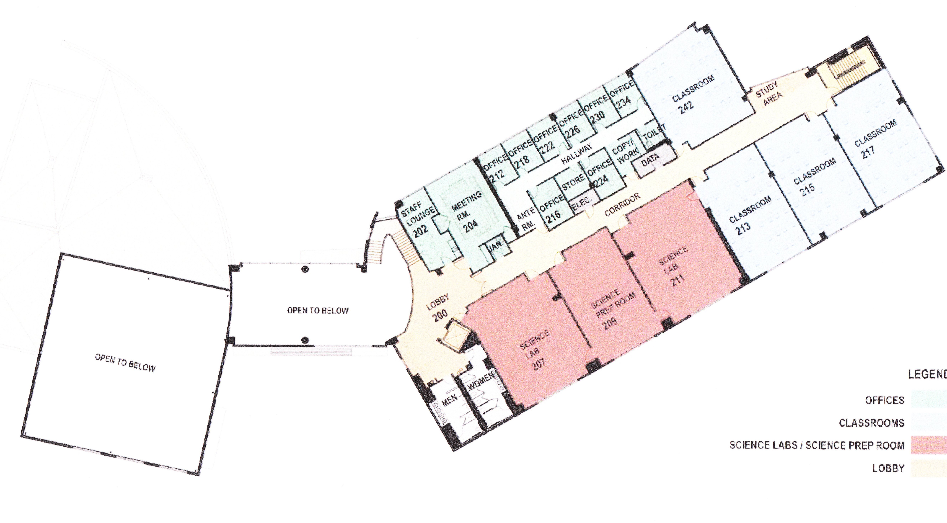
Classroom
213
My Office
RM 230
Second Floor Plan
First Floor Plan
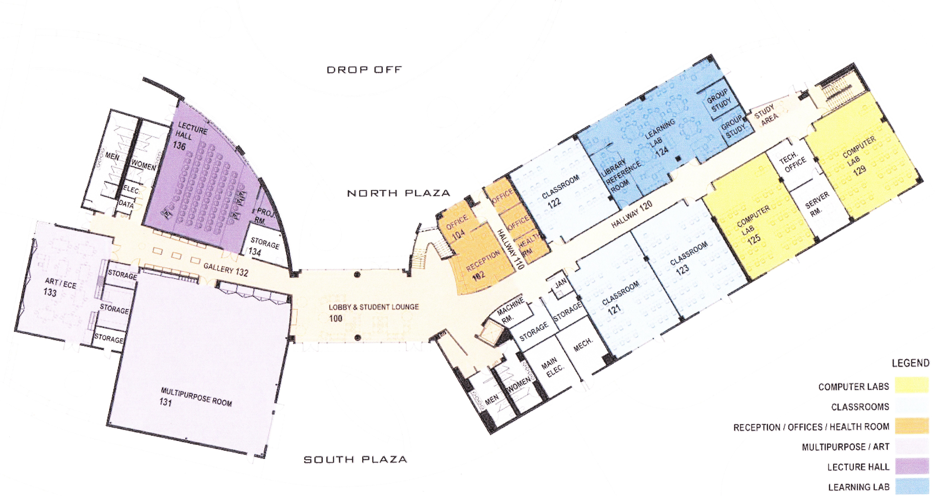
Learning Lab
Room 124

NOTE: The instructor reserves the right to change the syllabus and course outline at any time.
Students will be notified of changes in class.
* I reserve the right to make adjustments to the grading scale to cover special circumstanced – i.e. high score on the final, excessive absences, etc. Final grades will be determined by the total of scores on quizzes, homework, MAC hours, major exams and the final. At no time will grading be done on a curve.

