Elementary Algebra Homework – Sets

Name KEY
List all the subsets of each set given.
1. / 2. / ,,, 3. / ,,,
4. 5.
,,,,,,, ,,,,,,,
How many subsets does each of the following sets have?
6. / 7. / 8. /
Use the following sets to answer questions 9 – 34.
, ,
TRUE or FALSE?
9. False 13. and are disjoint. True
10. False 14. True
11. True 15. False
12. False 16. True
List the members of each set.
17. 20. 23.
18. 21. 24.
19. 22. 25.
Indicate each of the following on a Venn diagram.
26. 29. 32.
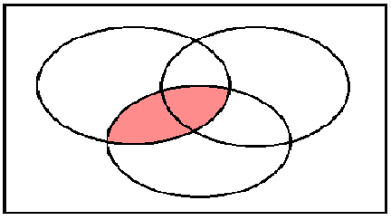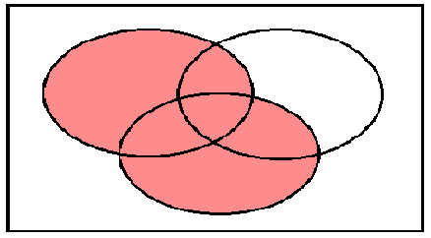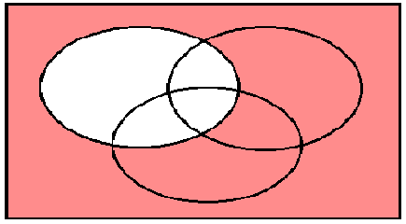
Y
X
Y
Z
X
Y
Z
X
Z
27. 30. 33.
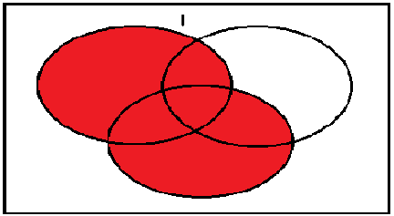
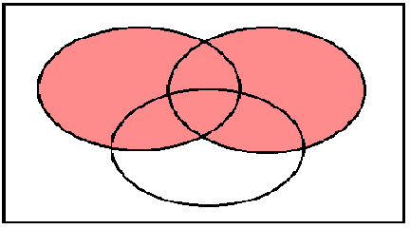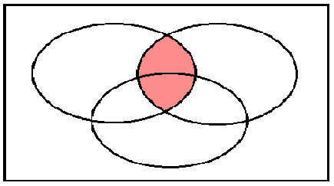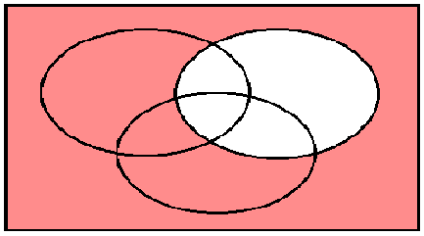
Z
X
X
Y
Z
X
Y
Z
Y
28. 31. 34.
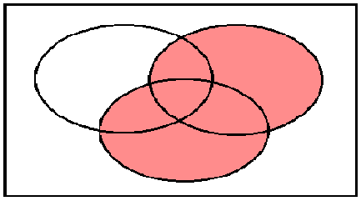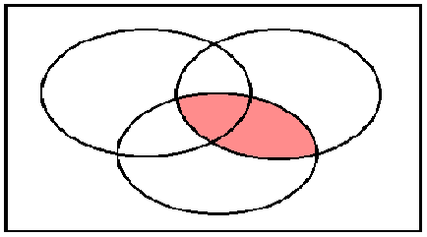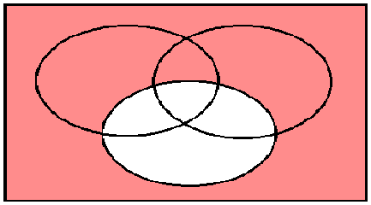
Z
Y
X
Y
Z
X
Y
X
Z

List the members of each of these sets.
35. and
36. and
37. and is a multiple of and
38. and and

