Elementary Algebra Homework - Sets

Name

List all the subsets of each set given.

1. 2. 3. 4. 5.

How many subsets does each of the following sets have?

6. 7. 8.

Use the following sets to answer questions 9 – 34.

TRUE or FALSE?

9. 13. and are disjoint.
10. 14.
11. 15.
12. 16.

List the members of each set.

17. 20. 23.
18. 21. 24.
19. 22. 25.

Indicate each of the following on a Venn diagram.

26. 29. 32.
27. 30. 33.
28. 31. 34.

List the members of each of these sets.

35. and
36. and
37. and is a multiple of and
38. and and
Answers to the odd numbered problems

1. 3. 5.

7. 32 9. False 11. False 13. True 15. False 17.

19. 21. 23. 25.

- 29.

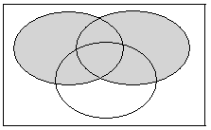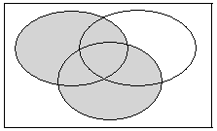
4
8
U
X
Y
6
10
1
Z
9
3
5 7
4
8
U
X
Y
6
10
1
Z
9
3
5 7
2
2

31. 33.
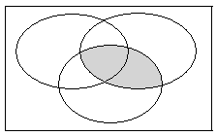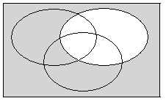
4
8
U
X
Y
6
10
1
Z
9
3
5 7
Y
Y’
9
3
1
2 4
8 10
6
5 7
2
35. 37.

