SUMMARY OF β -OXIDATION
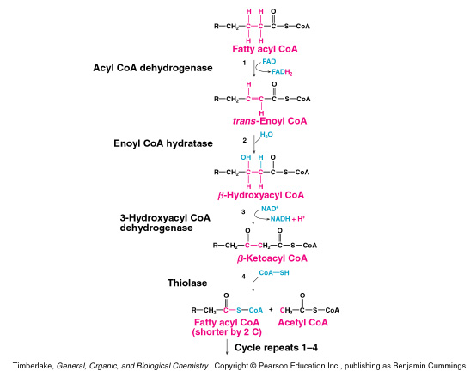
This is a fatty acid activated for metabolism. It takes two (2) ATP’s to activate it.
until two AcetylCoA are produced in Step 4 then it stops.

Summary of fatty acid metabolism:
Number of acetylCoA = n/2, where n=# carbon atom in fatty acid
Number of cycles = n/2 – 1
Each cycle produces 1 FADH₂ and 1 NADH

Total ATP produced:
one acetylCoA = 10 ATP by the citric acid cycle
one FADH₂ = 1.5 ATP by the electron transport chain
one NADH = 2.5 ATP by the electron transport chain

Myristic acid:
C₁₄H₂₈O₂ activation - 2 ATP
n=14; n/2 = 7 acetyl CoA 7 x 10 ATP = + 70 ATP
n/2 –1 = 6 cycles; 6 FADH₂ 6 x 1.5 ATP = + 9 ATP
6 NADH 6 x 2.5 ATP = + 15 ATP

TOTAL 92 ATP

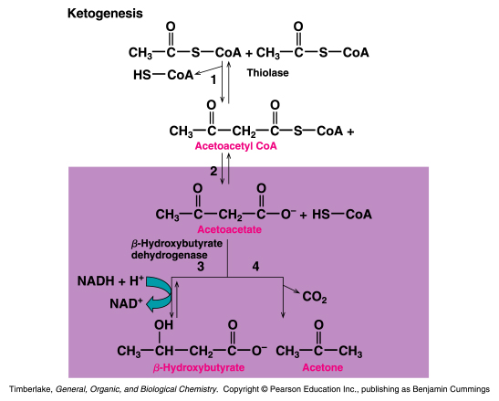
Keto acidosis occurs from over production and under utilization of ACETYLcoA
Keto acidosis occurs in starvation, diabetes and Atkinson diet.
KETONE BODIES
KETOGENESIS - PRODUCTION OF KETONE BODIES

