Answer questions 1-17 on your scantron. Each question is worth 2 pt. Mark only one answer for each question.

1) (4.5) Given the following number of protons (p), neutron (n) and electrons (e), which two the same element? Mark two.
A) p=16, n=16, e=16 B) p=15, n=16, e=18 C) p=16, n=15, e=16 D) p=17, n=15, e=18

2) (4.5) Given the following number of protons (p), neutron (n) and electrons (e), which of the following are isotopes? Mark all that apply.
A) p=10, n=11, e=10 B) p=10, n=10, e=10 C) p=9, n=10, e=10 D) p=8, n=8, e=10 E) all are isotopes

3) (4.6) Which elements will have similar properties? Mark all that apply.
A) carbon B) tin C) zirconium D) tellurium E) lead

4) (4.7 and 4.8) What do all the halogens have in common?
A) They all undergo similar reactions.
B) They all have similar properties.
C) They all form -1 ions.
D) They all have the same number of valence electrons.
E) all of the above

5) (4.7) Which of the following elements will form cations? Mark all that apply
A) Na B) C C) F D) Ca E) Ne

6) (9.4) What happens to an atom when it absorbs energy?
A) The atom stores the energy for later use.
B) The extra energy increases the speed of the electrons in their orbitals.
C) The atom re-emits the energy as heat.
D) The atom re-emits the energy as light.
E) none of the above

7) (9.6) The subshell letter:
A) specifies the 3-D shape of the orbital.
B) specifies the principal quantum number of the orbital.
C) specifies the maximum number of electrons.
D) specifies the principal shell of the orbital.

8) (9.6) What is the electron configuration for P?
A) [Ar]3s23p64s23d104p3
B) [Ne]1s21p62s22p3
C) [Ne]3s23p3
D) [Ar]3s23p3
E) none of the above

9) (9.6) Which principle energy level has the highest energy?
A) n=1 B) n=2 C) n=3 D) n=4 E) n=5

10) (9.6) Which subshell has the lowest energy?
A) 2s B) 2p C) 3s D) 3p E) 4s

11) (9.6) Which of the following electron configurations is not correct?
A) Br – 1s², 2s², 2p⁶, 3s², 3p⁶, 4s², 3d¹⁰, 4p⁵
B) Na - 1s², 2s², 2p⁶, 3s¹
C) H - 1s¹
D) Ne - 1s², 3s², 3p⁶

12) (9.7) Which of the following elements has the electron configuration of 3s23p4 in its outermost shell?
A) Al B) Si C) S D) Cl E) none of the above

13) (9.7) What element has 4 valence electrons in the 5th principle energy level?
A) carbon B) tin C) zirconium D) tellurium E) lead

14) (9.8) Which one of the following species has the electron configuration of 1s22s22p6? Mark all that apply.
A) Na⁺ B) Ca²⁺ C) N³⁻ D) Li⁺ E)

15) (9.9) Which of the following atoms is the largest?
A) Ba B) Ca C) K D) Sr E) Y

16) (9.9) Which of the following atoms has the least metallic character?
A) Na B) Be C) Rb D) Ti E) Ba

17) (10.3) Which of the following are ionic compounds? Mark all that apply.
A) NO₂ B) MgO C) KH D) NH₃ E) SF₂

Show all work for Questions 18 - 25 for complete credit. Round calculated answers to the correct number of significant figures.

18) (4.8) (11 pt) Fill in this table with the missing values, isotope formulas or names.
Isotope name | Isotope symbol | Atomic number | Mass number | Protons | Neutrons | Electrons | Charge
Iodine-131 |  |  |  |  |  |  | -1
 |  | 24 |  |  | 30 |  | +2

19) (4.5) (8 pt) Calculate the average atomic mass of an element that has three isotopes:
Percent Mass
Abundance
- Isotope 1 78.99% 23.9850419 amu
- Isotope 2 10.00% 24.9858370 amu
- Isotope 3 11.01% 25.9825930 amu
20) (2 pt) What elements is this?________________________________

21) (9.6) (10 pt) Draw the orbital diagram for vanadium.

22) (10.2 and 10.3) (8 pt) Draw a diagram using Lewis dot symbols showing how magnesium and chlorine trade electrons to make an ionic compound.
Lewis dot symbols of elements | Lewis dot symbols of ions | Formula of compound
39 pt

23) (10.5) Draw the Lewis structure of NH₂OH How many valence electrons are there?____________
Grading will be determined by:
2 pt valence electrons
1 pt arrangement of atoms
4 pt octet around all atoms
2 pt proper number of bonds to
each atom according to its
element.

24) (10.7) Fill in the following table for the following compound.
Lewis structure | Electron group name (4 pt) | Bond angle (2 pt) | Molecular geometry name (4 pt)
 | Around O:  Around N: | Around O:  Around N: | Around O:  Around N:

25. (14 pt) Complete the following table with either the name or formula of the compound or ion.
FORMULA | NAME
P₂O₅
K₂O
Cr₂(SO₄)₃
HC₂H₃O₂
NH₃
NH₄NO₂
AgBrO
 | Bromine
 | Manganese
 | Tin(IV) phosphate
 | Mercury(I) hydrogencarbonate
 | Calcium hydride
 | Sodium hydroxide
 | Periodic acid
33 pt

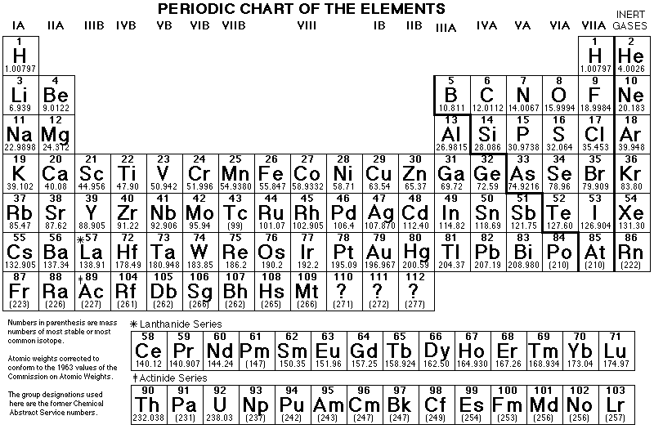

IF YOU THINK YOU NEED MORE INFORMATION JUST ASK.

SCRATCH

