Microscopic Properties of the Phases of Matter

PROPERTY | 11.4 SOLIDS | 11.5 LIQUIDS | 11.6 GASES
1. SHAPE | Definite – strong cohesive forces | Indefinite-cohesive forces not strong enough to prevent random movement | Indefinite-cohesive forces weak
2. VOLUME | Definite-strong cohesive forces | Definite-strong cohesive forces | Indefinite-cohesive forces weak
3. Density | Particles closely packed | Particles closely packed | Particles widely separated
4. Compressibility | Particles closely packed | Particles closely packed | Particles widely separated
5. Thermal expansion (thermometers) | Increased KE causes slight increase in space between particles | Increased KE causes slight increase in space between particles | Particles widely separated and have high KE and move further apart when

Solids and liquids have many similar properties ( )

Liquids and gases have many similar properties ( )
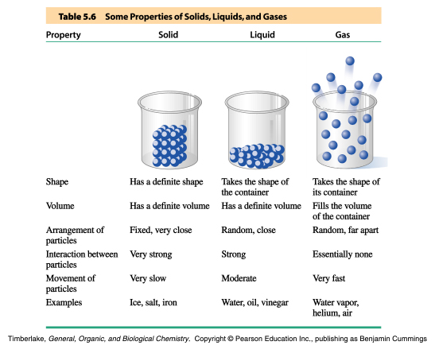

SOLID LIQUID GAS

freezing
melting or fusion
condensation
evaporation
deposition
sublimation
freezing
melting or fusion
condensation
evaporation
sublimation
deposition
CHANGES OF STATE)

sublimation point
vapor
solid
boiling point
vapor
liquid
melting point or
freezing point
liquid
solid
PHYSICAL PROPERTY
CHANGES OF STATE

exothermic
endothermic
exothermic
enodthermic
exothermic
endothermic
exothermic
endothermic
exothermic
endothermic
Add heat=endothermic
Remove heat=exothermic
ENERGY CHANGES IN CHANGES OF STATE

boiling point
vapor
solid
freezing point
vapor
liquid
melting point

liquid
solid
PHYSICAL PROPERTY
CHANGES OF STATE
sublimation point

SOLID LIQUID GAS

