FAMILY OF D-ALDOSES

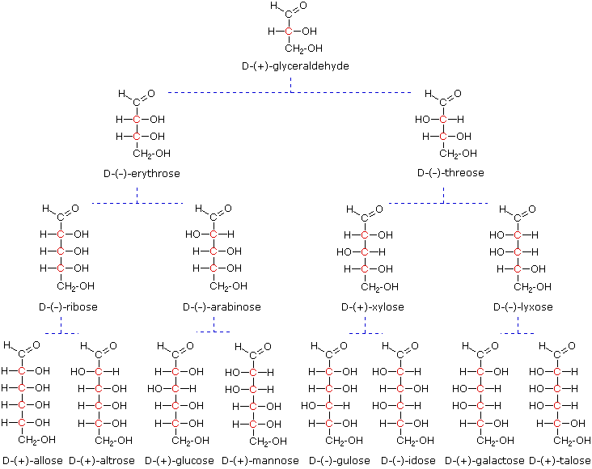

FAMILY OF D-KETOSES
Notice these ketoses have one less stereocenter than the corresponding aldoses, so there are not as many stereoisomers.

dihydroxyacetone
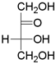
D-glycerotetrulose
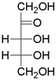 |  |  |  | 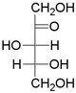
D-erythropentulose |  |  |  | D-threopentulose
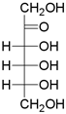 |  | 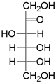 |  | 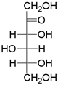 |  | 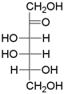
D-psicose | D-fructose |  | D-sorbose |  | D-tagatose

