ACTIVATION OF FATTY ACIDS
and transport into mitochondria for β-oxidation catabolism.

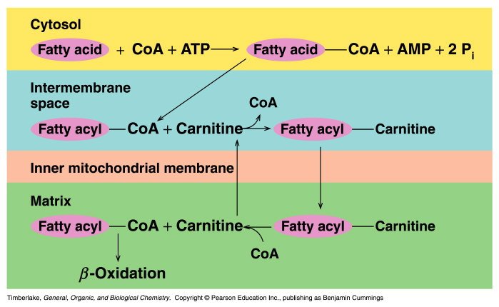
mitochondria

transported into mitochondria matrix and reactivated for β -oxidation

SUMMARY OF β -OXIDATION
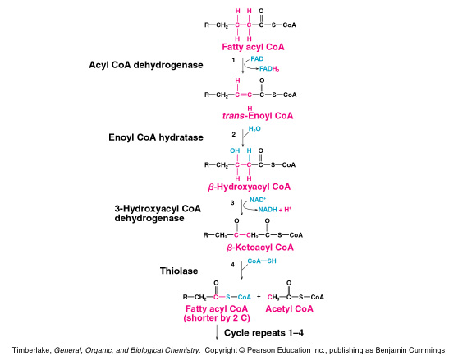

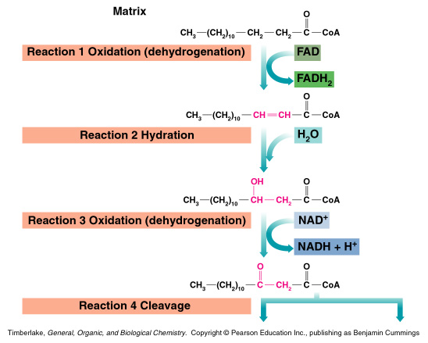
FAD used for making C=C
NAD⁺ used for making C=O
MITOCHONDRIA MATRIX

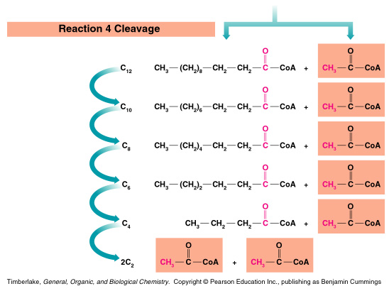
FIRST CYCLE

2ND CYCLE

3RD CYCLE

4TH CYCLE

5TH CYCLE
6TH CYCLE

Summary of fatty acid metabolism:
Number of acetylCoA = n/2, where n=# carbon atom in fatty acid
Number of cycles = n/2 – 1
Each cycle produces 1 FADH₂ and 1 NADH

Total ATP produced:
one acetylCoA = 10 ATP by the citric acid cycle
one FADH₂ = 1.5 ATP by the electron transport chain
one NADH = 2.5 ATP by the electron transport chain

Myristic acid:
C₁₄H₂₈O₂ activation - 2 ATP
n=14; n/2 = 7 acetyl CoA 7 x 10 ATP = + 70 ATP
n/2 –1 = 6 cycles; 6 FADH₂ 6 x 1.5 ATP = + 9 ATP
6 NADH 6 x 2.5 ATP = + 15 ATP

TOTAL 92 ATP

Glycerol metabolism

Net ATP from glycerol: -1 ATP -1 ATP
(in cytosol) + 2 NADH x 1.5 ATP = 3 ATP
+ 2 ATP 2 ATP
Net ATP from pyruvate: + 1 NADH x 2.5 ATP = 2.5 ATP
Net ATP from acetylCoA: 1 x 10 ATP = 10 ATP

Total 16.5 ATP

ATP in glyceryl trimyristate:

1 – glycerol : 1 x 16 ATP = 16.5 ATP
3- myristic acids: 3 x 92 ATP = 276 ATP

Total 292.5 ATP

COMPARING ATP FROM VARIOUS SOURCES
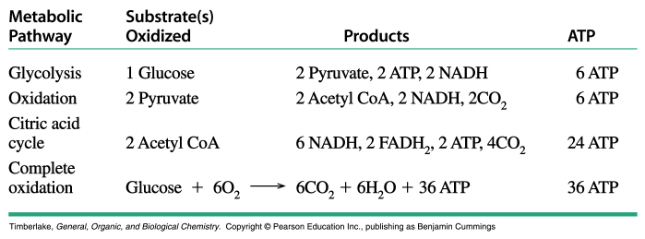

5 ATP
5ATP
20 ATP
30 ATP

ATP’s per carbon atom in:

Glucose: 30 ATP / 6 C = 5 ATP / C
Myristic acid: 92 ATP / 14 C = 6.6 ATP / C
Glyceryl trimyristate: 292.5 ATP / 45 C = 6.5 ATP / C

Fatty acids give more energy than glucose because they start off in a more reduced state. Remember oxidation = energy and fatty acids require more oxidation.

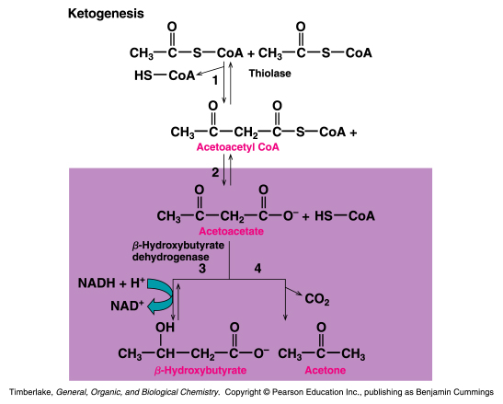
Keto acidosis occurs from over production and under utilization of ACETYLcoA
Keto acidosis occurs in starvation, diabetes and Atkinson diet.
KETONE BODIES
KETOGENESIS - PRODUCTION OF KETONE BODIES

