Amino Acid Structures
These are L-α-aminoacids shown in their Fischer projections.
The structures are listed in alphabetical order. Ionizable groups (amino and carboxyl) are shown in their neutral form - this implies absolutely nothing about the predominant form at any particular pH. These neutral forms DO NOT exist at any pH.
carboxyl
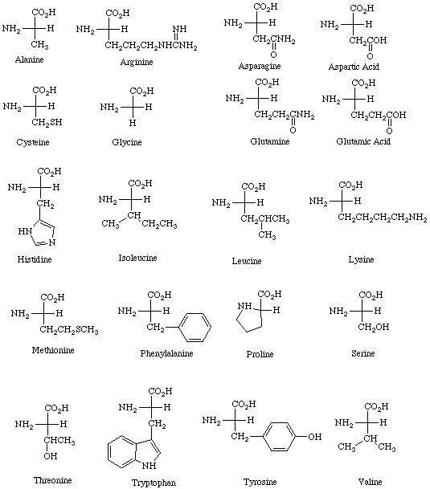
amino
The following table gives the pKa values for the α-carboxylic acid group, the α-amino group, and any ionizable side chains.

Amino Acid pKa Values
Amino Acid | α-carboxylic acid | α-amino | Side chain
Alanine | 2.35 | 9.87
Arginine | 2.01 | 9.04 | 12.48
Asparagine | 2.02 | 8.80
Aspartic Acid | 2.10 | 9.82 | 3.86
Cysteine | 2.05 | 10.25 | 8.00
Glutamic Acid | 2.10 | 9.47 | 4.07
Glutamine | 2.17 | 9.13
Glycine | 2.35 | 9.78
Histidine | 1.77 | 9.18 | 6.10
Isoleucine | 2.32 | 9.76
Leucine | 2.33 | 9.74
Lysine | 2.18 | 8.95 | 10.53
Methionine | 2.28 | 9.21
Phenylalanine | 2.58 | 9.24
Proline | 2.00 | 10.60
Serine | 2.21 | 9.15
Threonine | 2.09 | 9.10
Tryptophan | 2.38 | 9.39
Tyrosine | 2.20 | 9.11 | 10.07
Valine | 2.29 | 9.72
Last modified 2/4/97

Abby Parrill
Department of Chemistry
Michigan State University
These pages may be downloaded and linked from other pages freely for academic and educational purposes. Questions, problems, and errors should be sent toparrill@argus.cem.msu.edu.

