Math 102 – Quiz #3 (Sections R.4 – R.6, 1.1) Name ______________________________
Show work to receive credit!
1. Perform the indicated operations. Write final answers in reduced form. (SHOW STEPS)
a. b.

c. d.

2. The following bar graph displays the number of students in 5th, 6th, 7th, and 8th grade student who ride the bus to school.
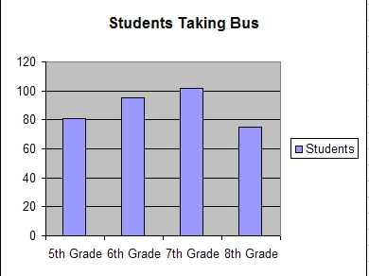

a. Which class has the greatest number of students who ride the bus? _________________

b. Estimatre the total number of students who ride the bus to school. __________________

c. How many more 6th students take the bus than 8th grade students? ___________________

(more on the other side…)
3. a. Plot the following points on the grid. ( –2 , 1 ) and ( 3 , –2 )
 |  |  | 4
 |  |  | 3
 |  |  | 2
 |  |  | 1
-3 | -2 | -1 | 0 | 1 | 2 | 3 | 4
 |  |  | -1
 |  |  | -2
 |  |  | -3
b. Draw a right triangle with distance between the points as the hypotenuse.
c. Find the rise and the run.

RISE =

RUN =

d. Find the distance between these two points. Give both the exact answer and the decimal estimate, rounded to two decimal places.

EXACT distance =

DECIMAL ESTIMATE, distance

4. Find the area and perimeter of the region shown. Assume the units are inches.

AREA =

PERIMETER =

5. Convert the following into variable expressions.
a. Three less than the product of four and the variable s __________________________________

b. Two more than the quotient of the variable x and five __________________________________

6. Evaluate the polynomial when . Show your work.

